Appendix D
USER MANUAL

Table of Contents
- System Overview--------------------------------------------------------------------------------------
- System Requirements---------------------------------------------------------------------------------
- User Roles and Access Levels-----------------------------------------------------------------------
- Login and Authentication-----------------------------------------------------------------------------
- System Dashboard and Navigation------------------------------------------------------------------
- Features and Modules---------------------------------------------------------------------------------
- Role-Based User Guide-------------------------------------------------------------------------------
- Common Tasks-----------------------------------------------------------------------------------------
- Troubleshooting----------------------------------------------------------------------------------------
- Logout Procedure--------------------------------------------------------------------------------------

1. System Overview
1.1 Introduction
IntellEvalPro is a web-based Faculty Evaluation System designed to automate the process of evaluating faculty performance in an academic institution. It provides a centralized platform for managing users, academic years, evaluation periods, faculty records, student records, questionnaires, reports, and analytics.
The system helps institutions collect student feedback in an organized, secure, and role-based environment. It also supports monitoring, analysis, and reporting of evaluation results for administrative and academic decision-making.
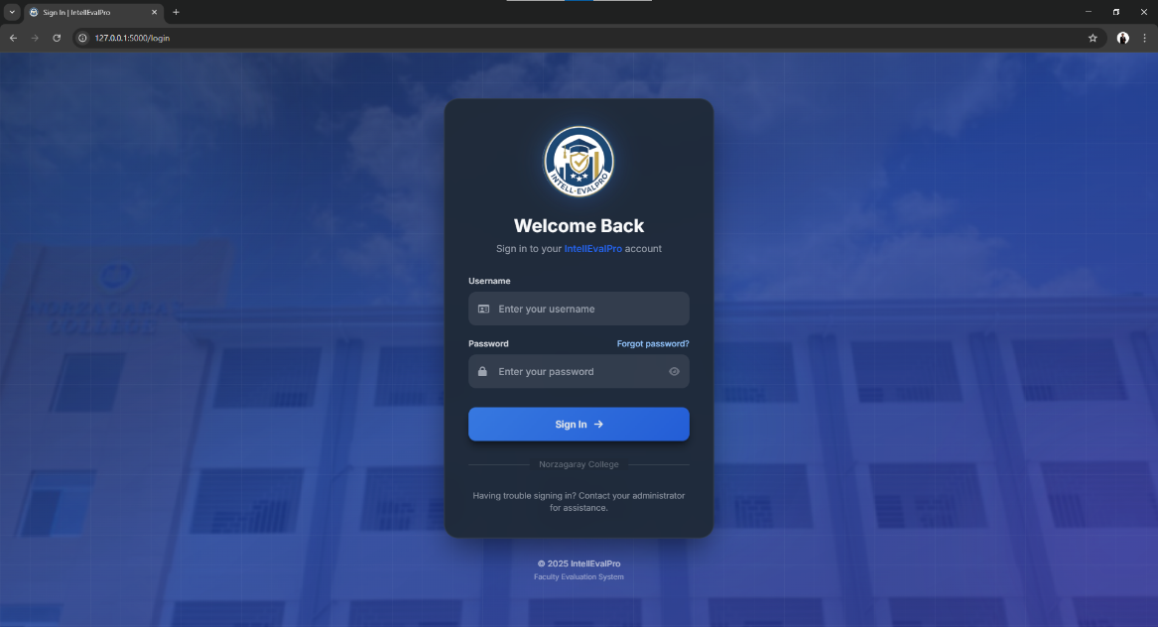

Figure 1. System Login Page or Home Interface
1.2 Purpose of the System
The system was developed to:
- Automate the faculty evaluation process.
- Reduce manual handling of evaluation forms and reports.
- Provide secure role-based access to users.
- Improve monitoring of evaluation participation and completion.
- Generate reports and analytics for institutional use.
1.3 Objectives
- To provide a digital platform for faculty evaluation.
- To allow students to evaluate assigned faculty members online.
- To help administrators manage institutional evaluation records.
- To support Guidance and Dean users with analytics and reports.
- To maintain accurate and organized evaluation data.

2. System Requirements
2.1 Hardware Requirements
Client Computer
- Processor: Dual-core 2.0 GHz or higher
- RAM: 4 GB minimum
- Storage: At least 500 MB free space
- Monitor Resolution: 1366 x 768 or higher
- Keyboard and mouse or touchscreen device
Server or Host Computer
- Processor: Quad-core 2.4 GHz or higher
- RAM: 8 GB or higher
- Storage: At least 20 GB free space
- Stable local network or internet connection
- Database-ready system for MySQL
2.2 Software Requirements
- Operating System: Windows 10 or Windows 11
- Python 3.9 or higher
- MySQL 8.0 or higher
- XAMPP or equivalent local server environment
- Required Python libraries installed from the project requirements
2.3 Browser Requirements
The system can be accessed using:
- Google Chrome
- Microsoft Edge
- Mozilla Firefox
- Safari
2.4 Recommended Browser
Google Chrome or Microsoft Edge is recommended for best compatibility and performance.

3. User Roles and Access Levels
IntellEvalPro uses role-based access control. Each user has access only to the modules assigned to their role.
3.1 Superadmin
The Superadmin is responsible for top-level technical monitoring and system oversight.
Access Rights
- View system dashboard
- Monitor system health
- Access activity monitor
- View terminal output
- Access database browser
- Manage user accounts
3.2 Admin
The Admin is responsible for system setup and operational management.
Access Rights
- Manage academic years
- Manage evaluation periods
- Manage users
- Manage faculty
- Manage students
- Manage subjects
- Manage sections
- View archives
- View activity logs
- Generate reports
3.3 Guidance Counselor
The Guidance user is responsible for evaluation oversight, analytics, questionnaires, reports, and rankings.
Access Rights
- View guidance dashboard
- Manage evaluation periods
- Monitor evaluation completion
- View evaluation results
- Manage questionnaires
- View analytics and rankings
- Export reports
- Control dean access
3.4 Dean
The Dean is responsible for reviewing department-level faculty evaluation results.
Access Rights
- View dean dashboard
- Access department faculty list
- View department evaluation results
- View department rankings
- View department analytics
- Generate department reports
Important Note
Dean access to results depends on approval from Guidance.
3.5 Student
The Student is responsible for completing evaluations assigned to them.
Access Rights
- View student dashboard
- Open pending evaluations
- Complete evaluation forms
- View evaluation history
- Change account password
3.6 Faculty
In the current implementation, faculty members are maintained as records for evaluation purposes. A faculty self-service portal is not currently active.

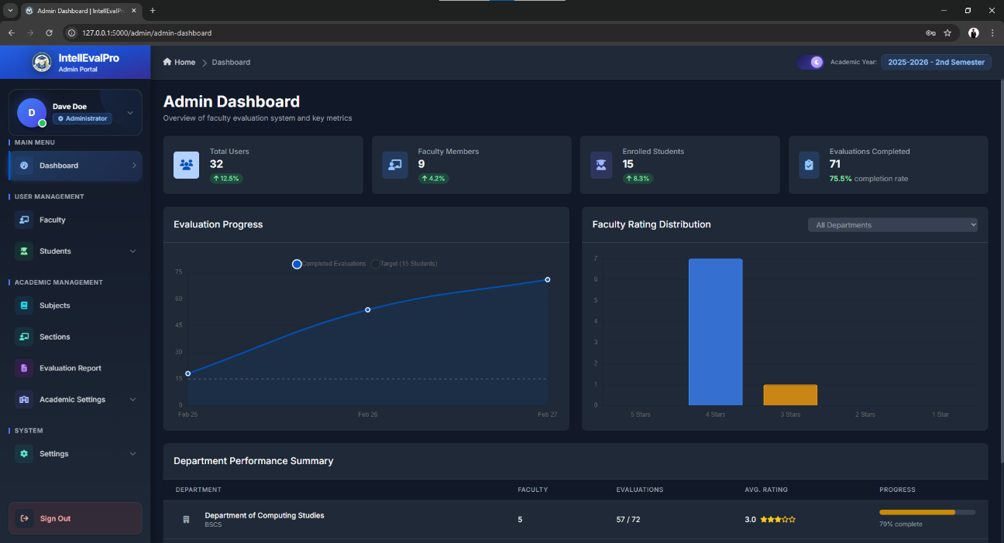

Figure 2. Example Dashboard Access by Role

4. Login and Authentication
4.1 Login Procedure
To access the system, follow these steps:
- Open the IntellEvalPro website in your browser.
- Wait for the Login page to load.
- Enter your username.
- Enter your password.
- Click the Login button.
- If Multi-Factor Authentication is required, complete the verification step.
- After successful authentication, the system redirects you to your assigned dashboard.
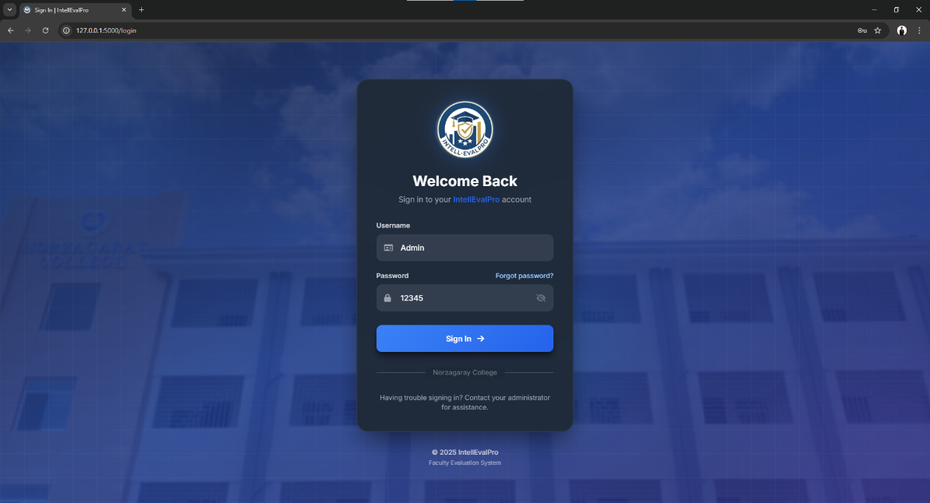

Figure 3. Login Interface

4.2 Forgot Password Procedure
If you forget your password, follow these steps:
- Click Forgot Password on the Login page.
- Enter your registered email address.
- Click Submit.
- Open the password reset email.
- Click the reset link.
- Enter a new password.
- Confirm the new password.
- Submit the form.
- Return to the Login page and sign in again.
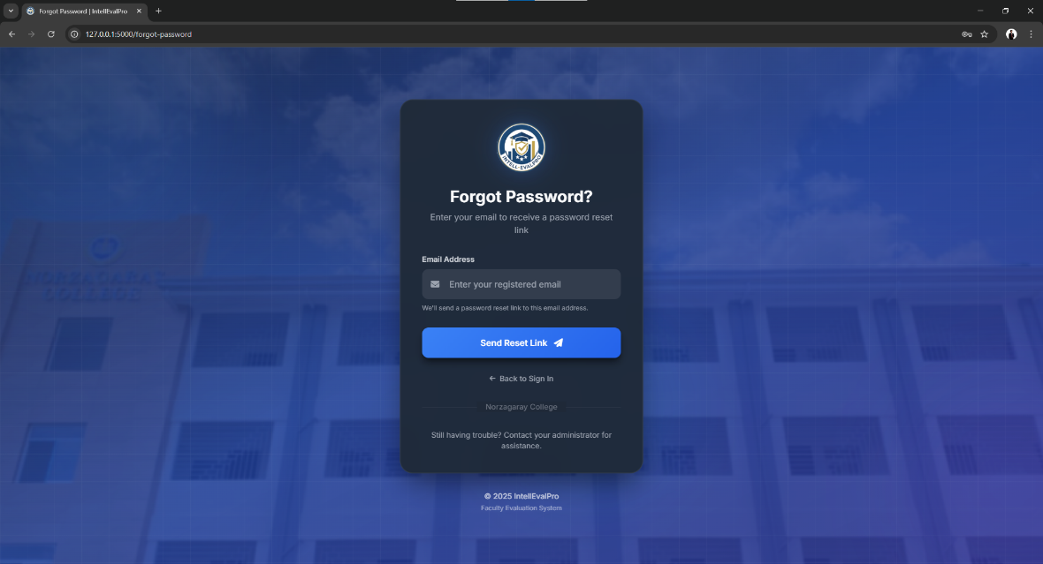

Figure 4. Forgot Password Page

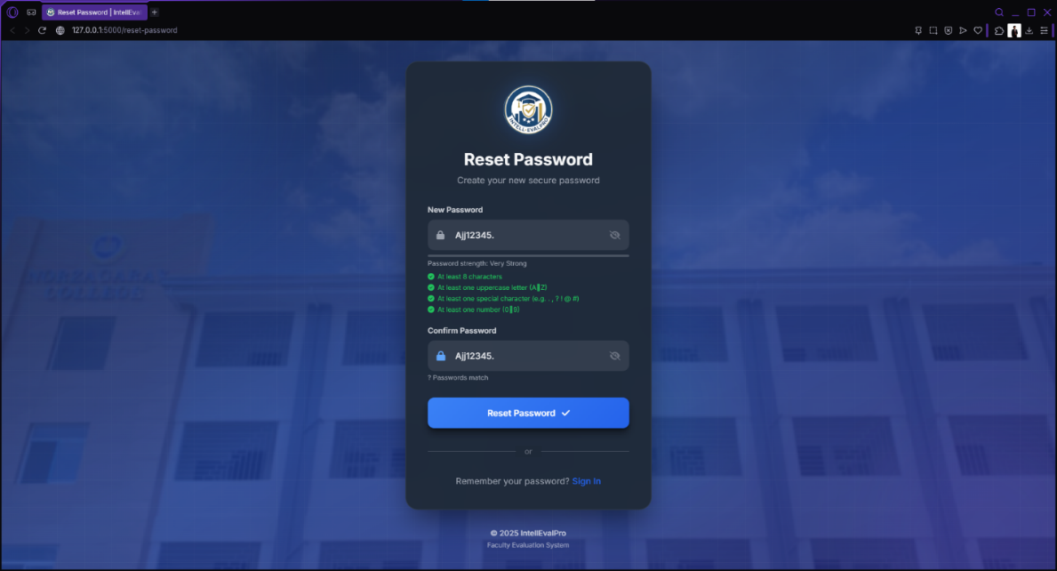

Figure 5. Reset Password Page

4.3 Password Requirements
A valid password must:
- Have at least 8 characters
- Include at least one uppercase letter
- Include at least one number
- Include at least one special character
4.4 Important Authentication Notes
- Students can log in only during an active evaluation period.
- Graduated students may not be allowed to continue evaluation access.
- Dean accounts require approval from Guidance before viewing results.
- Faculty login is currently unavailable in the live implementation.

5. System Dashboard and Navigation
5.1 Dashboard Overview
After login, the user is taken to a role-specific dashboard. The dashboard provides a summary of important information and quick access to system functions.
Common Dashboard Elements
- Summary cards
- Navigation menu
- Current academic term or evaluation period
- Quick action buttons
- Reports, charts, or progress indicators
5.2 Navigation Menu
The navigation menu allows users to move between system modules.
General Navigation Procedure
- Click a menu item to open a page.
- The current page is highlighted.
- Use the profile area for account settings or logout.
- Some pages include search, filters, and export buttons.
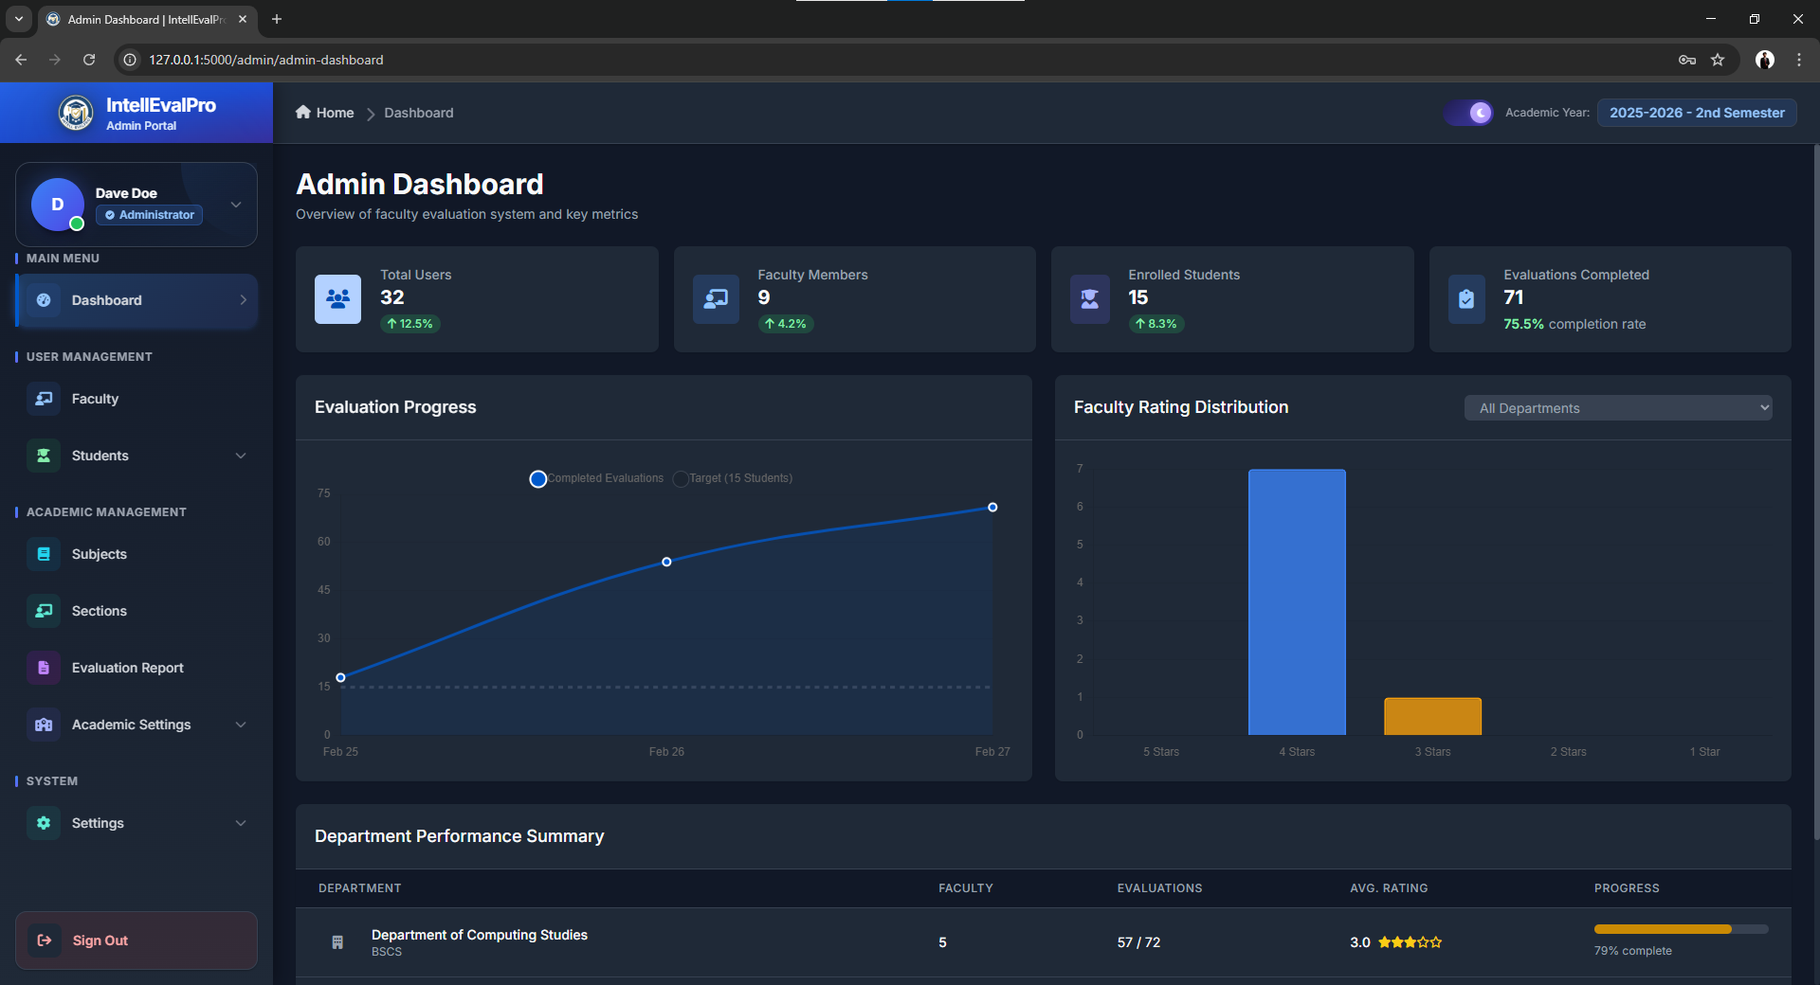
Figure 6. Example Navigation Menu
5.3 Dashboard Screens by Role

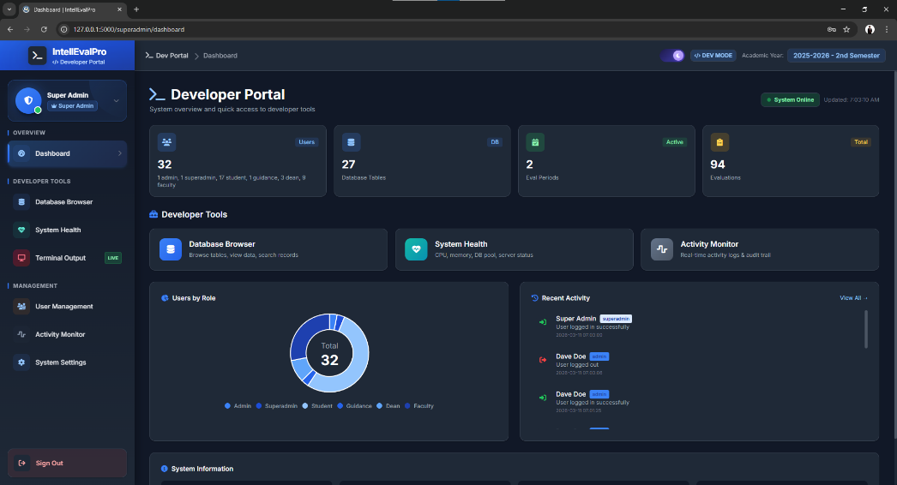

Figure 7. Superadmin Dashboard
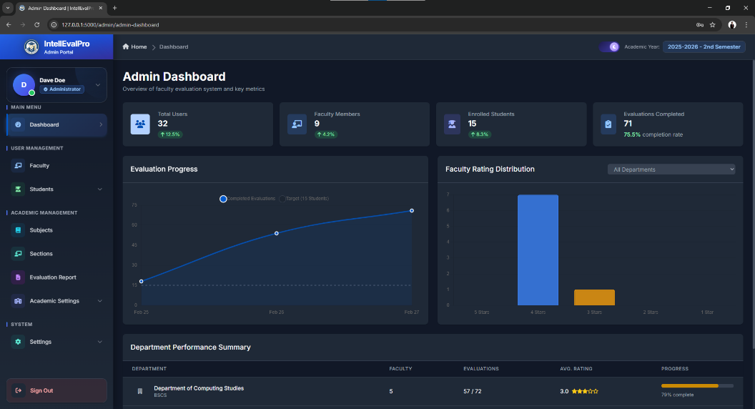

Figure 8. Admin Dashboard
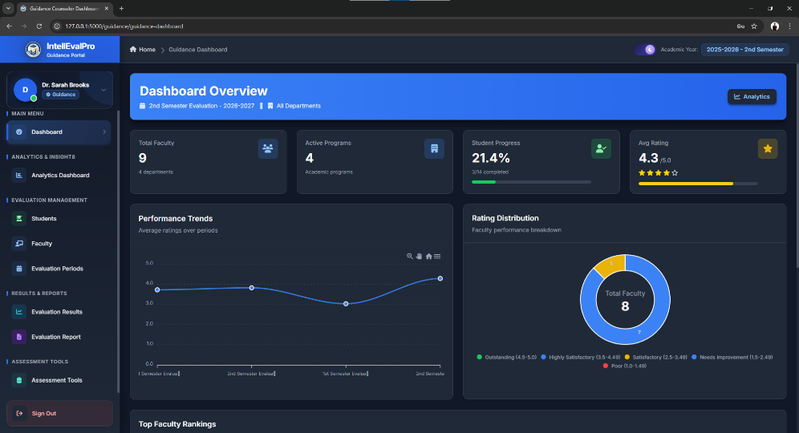

Figure 9. Guidance Dashboard

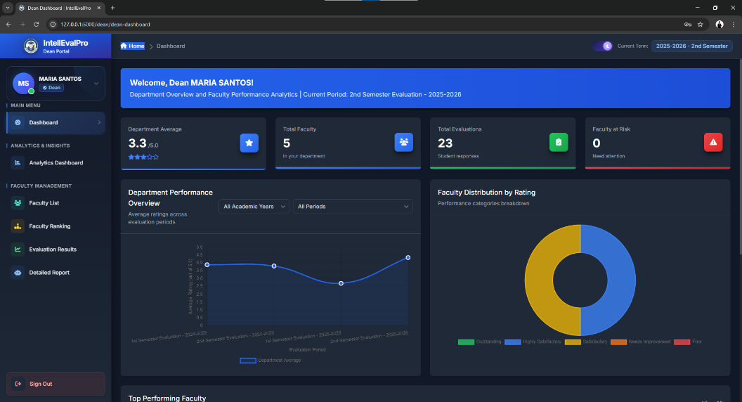

Figure 10. Dean Dashboard
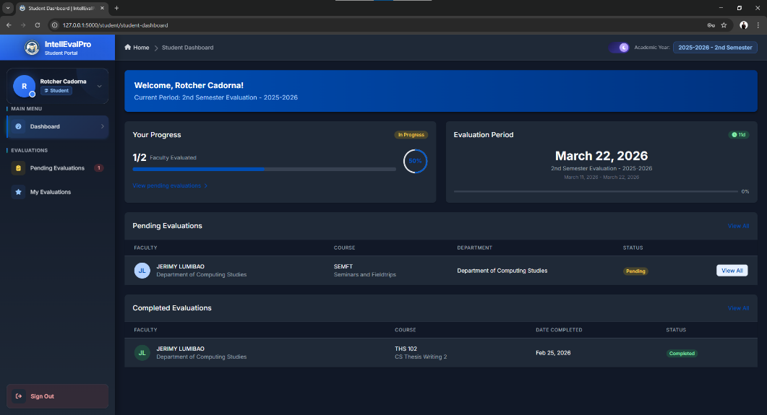

Figure 11. Student Dashboard

6. Features and Modules
6.1 Academic Year Management
Purpose
This module is used to create and manage academic years and terms used by the system.
Procedure
- Log in as Admin.
- Open the Academic Years module.
- Click Add Academic Year.
- Enter the required details.
- Save the record.
- Set the active academic year if needed.
Expected Result
The academic year is created and becomes available for other modules.
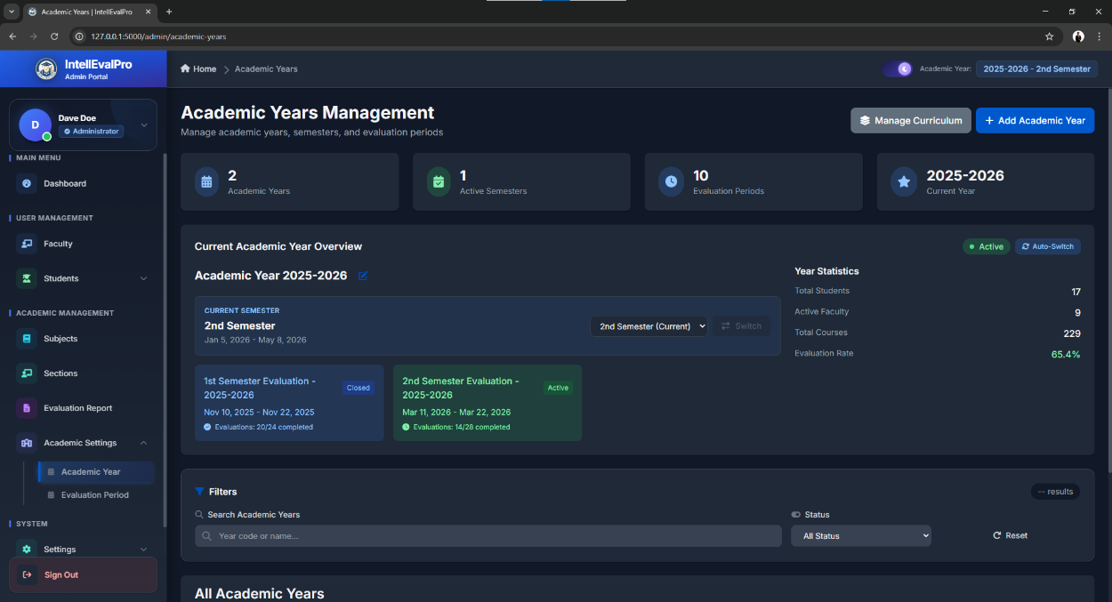

Figure 12. Academic Year Management Page

6.2 Evaluation Period Management
Purpose
This module is used to create and manage evaluation periods for student submissions.
Procedure
- Log in as Admin or Guidance.
- Open Evaluation Periods.
- Click Add Evaluation Period.
- Enter the title, schedule, and academic term.
- Set the period status.
- Save the record.
Expected Result
The evaluation period is successfully created and becomes available for monitoring and student evaluation.
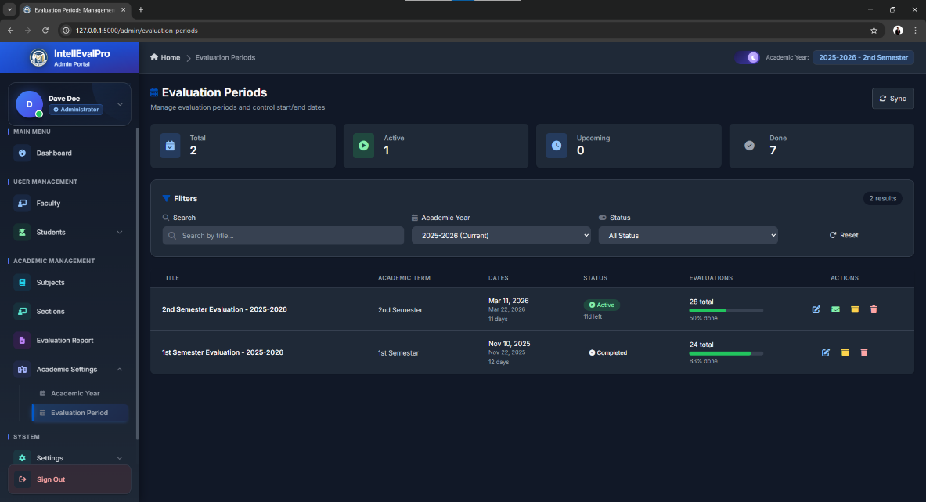

Figure 13. Evaluation Period Management Page

6.3 User Management
Purpose
This module is used to manage user accounts.
Procedure
- Log in as Admin or Superadmin.
- Open User Management.
- Click Add User.
- Enter the username, email, role, and password.
- Save the record.
- Edit, reset, or delete users if needed.
Expected Result
The user account is created or updated successfully.

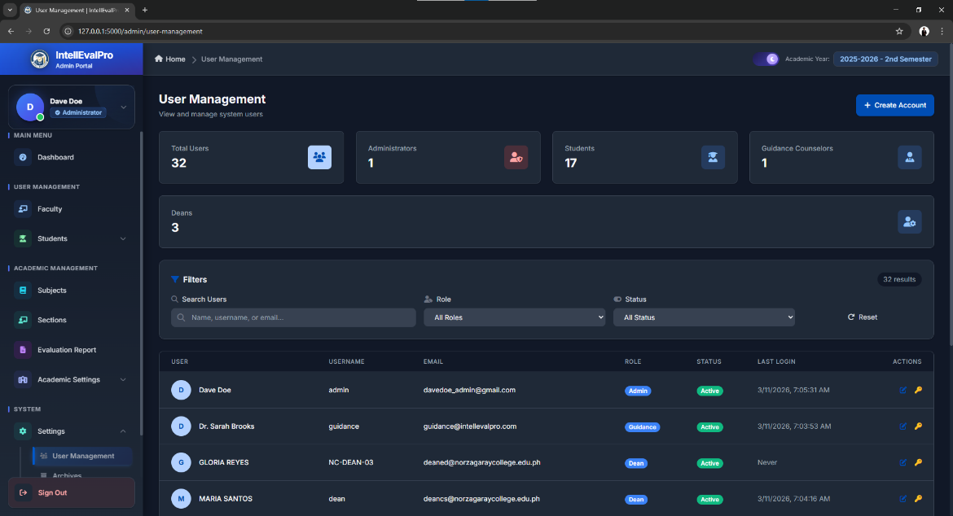

Figure 14. User Management Page

6.4 Faculty Management
Purpose
This module is used to manage faculty records and assignments.
Procedure
- Log in as Admin.
- Open Faculty List.
- Click Add Faculty.
- Enter the required faculty details.
- Save the record.
- Assign subjects or sections if needed.
Expected Result
The faculty member is added to the system and can be included in evaluations.
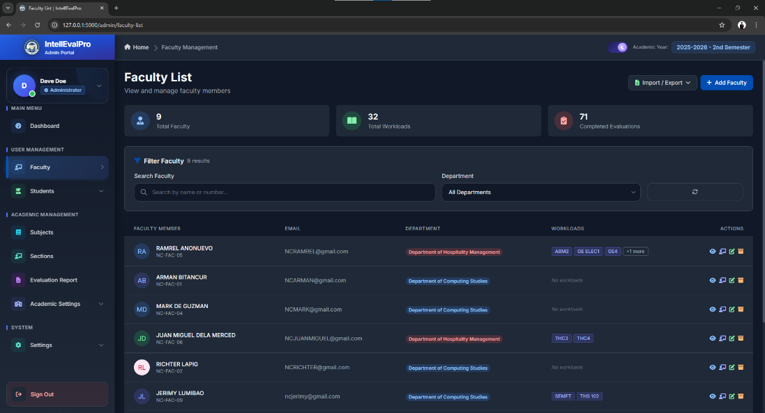

Figure 15. Faculty Management Page

6.5 Student Management
Purpose
This module is used to manage student records and section assignments.
Procedure
- Log in as Admin.
- Open Student List.
- Click Add Student.
- Enter the student details.
- Assign the correct section and year level.
- Save the record.
Expected Result
The student is added to the system and can participate in evaluations.
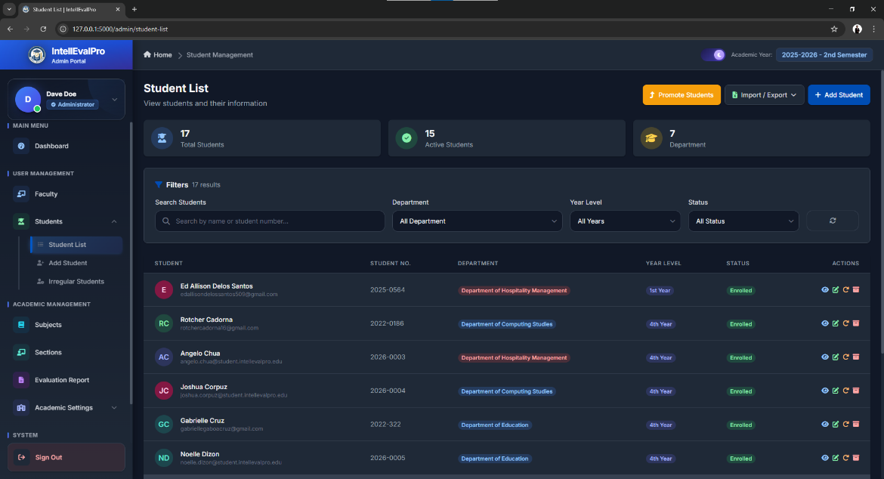

Figure 16. Student Management Page

6.6 Subject Management
Purpose
This module is used to manage the subjects offered by the institution.
Procedure
- Log in as Admin.
- Open Subjects.
- Click Add Subject.
- Enter the subject code, title, and description.
- Save the subject.
Expected Result
The subject is stored and can be assigned to faculty and class sections.
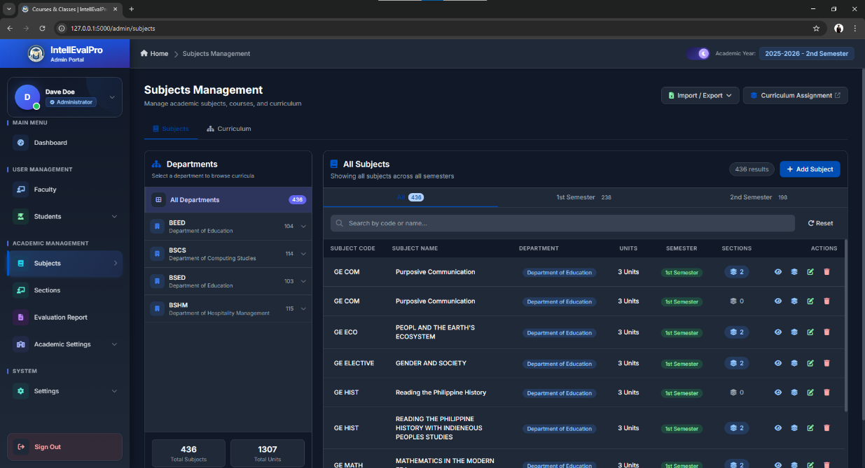

Figure 17. Subject Management Page

6.7 Section Management
Purpose
This module is used to organize students into sections.
Procedure
- Log in as Admin.
- Open Sections.
- Click Add Section.
- Enter the section details.
- Save the section.
- Manage student assignments if necessary.
Expected Result
The section is created and can be used in class and evaluation mapping.
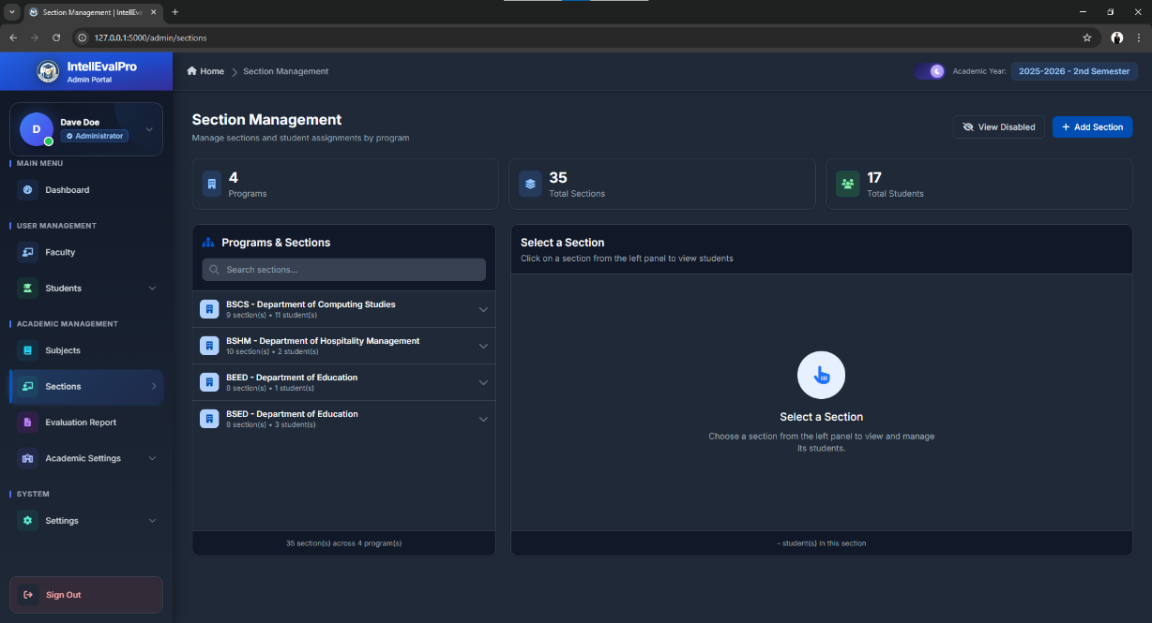

Figure 18. Section Management Page

6.8 Questionnaire Management
Purpose
This module is used to create evaluation categories and criteria.
Procedure
- Log in as Guidance.
- Open Questionnaire Management.
- Add or edit categories.
- Add or edit criteria under each category.
- Arrange the order if needed.
- Save the questionnaire.
Expected Result
The questionnaire becomes available for use in evaluation periods.
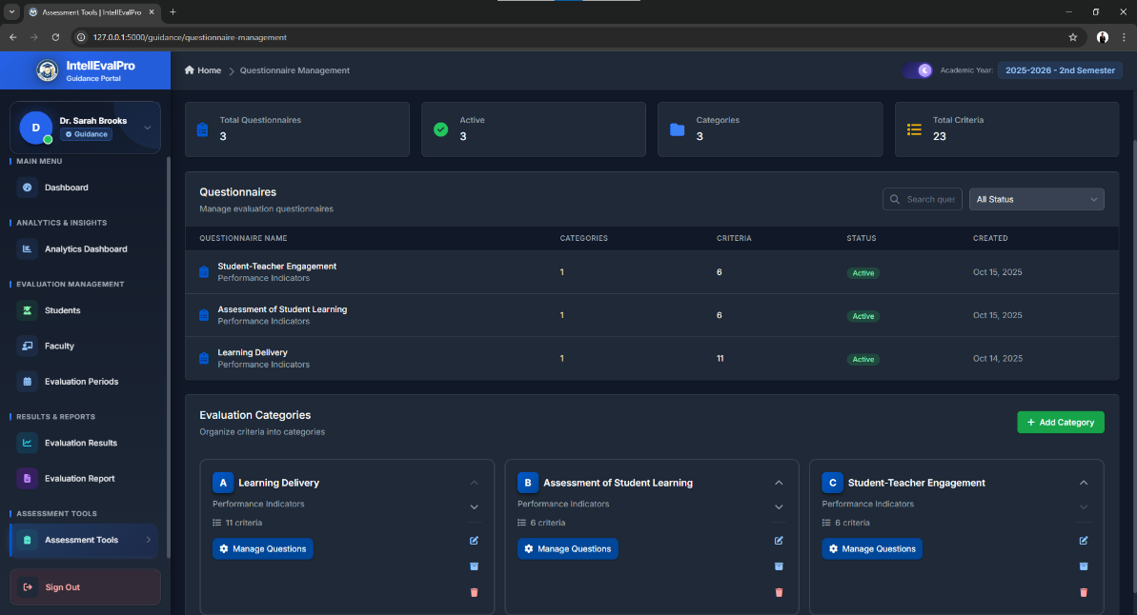

Figure 19. Questionnaire Management Page

6.9 Student Evaluation Module
Purpose
This module allows students to complete evaluations for assigned faculty members.
Procedure
- Log in as Student.
- Open Pending Evaluations.
- Select an assigned evaluation.
- Review the subject and faculty details.
- Answer all evaluation questions.
- Add comments if applicable.
- Submit the evaluation.
Expected Result
The evaluation is saved and marked as completed.
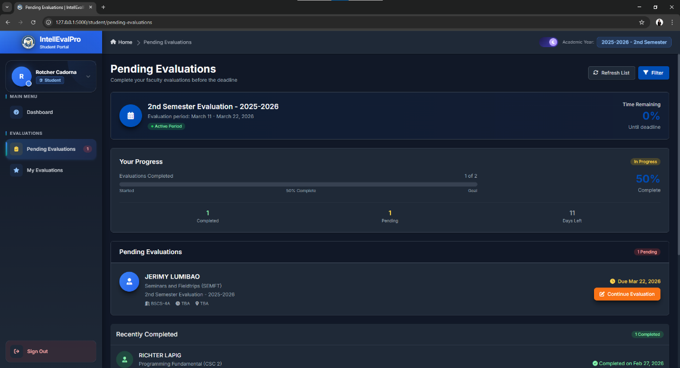

Figure 20. Pending Evaluations Page
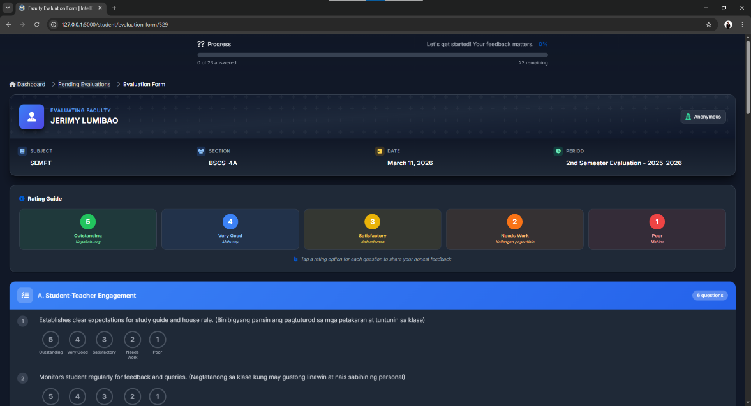

Figure 21. Student Evaluation Form

6.10 Evaluation Results
Purpose
This module provides access to completed evaluation results.
Procedure
- Log in as Guidance, Admin, or Dean.
- Open Evaluation Results.
- Select the academic year and evaluation period.
- Apply filters if needed.
- Review faculty scores, comments, and summaries.
Expected Result
The selected evaluation results are displayed.
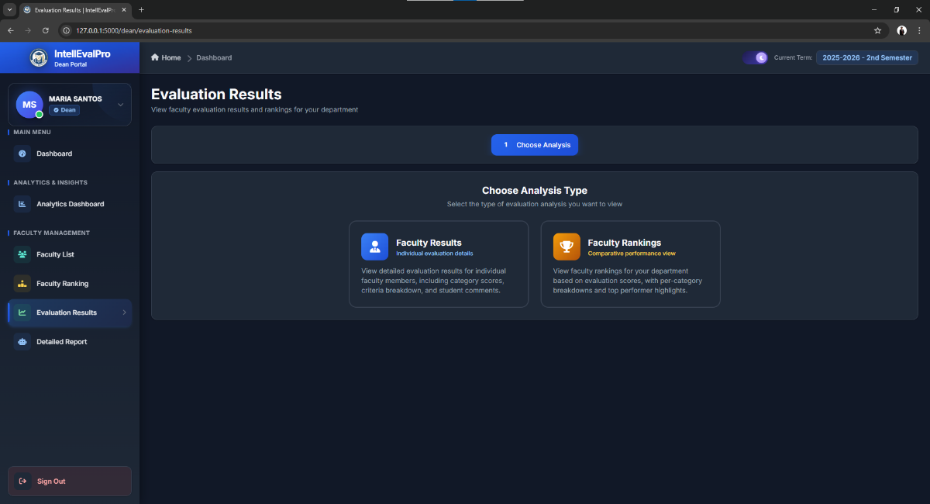

Figure 22. Evaluation Results Page

6.11 Reports and Export
Purpose
This module allows authorized users to generate exportable reports.
Procedure
- Log in as Admin, Guidance, or Dean.
- Open Evaluation Reports.
- Select the scope of the report.
- Choose a format such as PDF or Excel.
- Generate the report.
- Download the file.
Expected Result
A report is generated and made available for download.
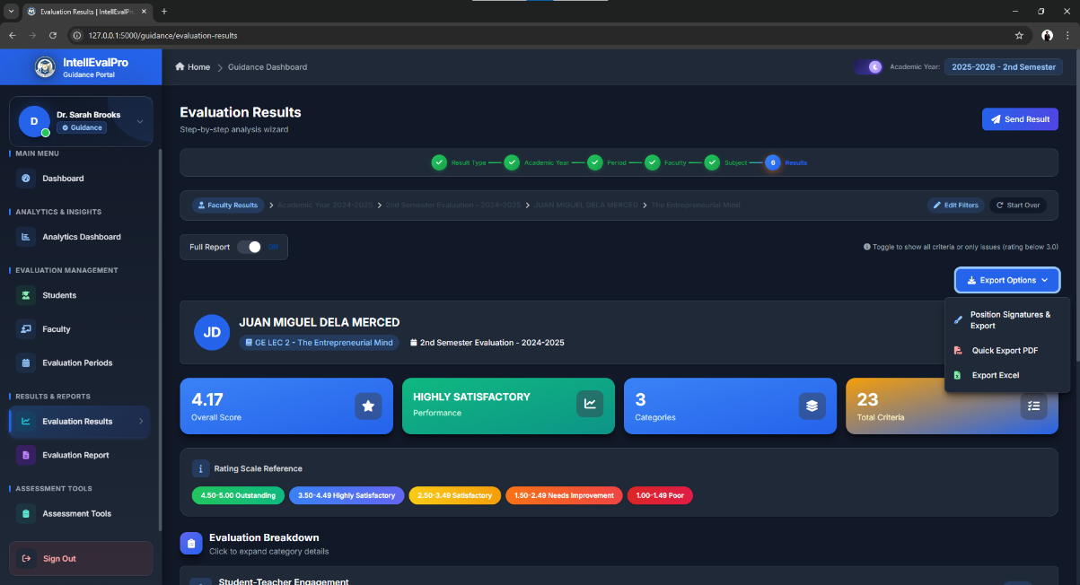

Figure 23. Report Generation Page

6.12 Rankings and Analytics
Purpose
This module displays charts, trends, rankings, and analytics for faculty performance.
Procedure
- Log in as Guidance or Dean.
- Open Rankings or Analytics Dashboard.
- Apply the appropriate filters.
- Review the charts, trends, and summaries.
- Export the results if needed.
Expected Result
The system displays performance insights for analysis and decision-making.
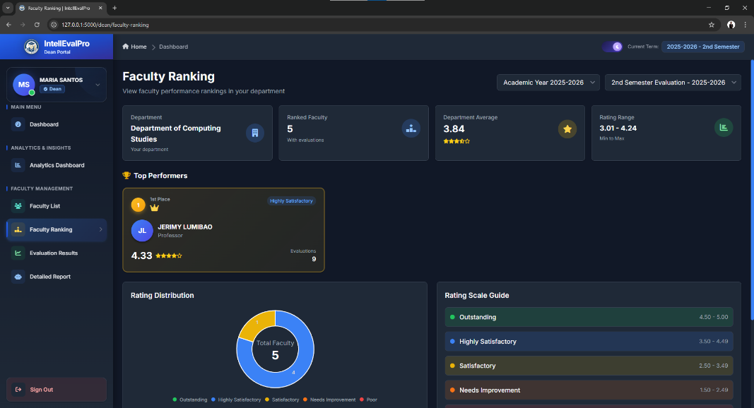

Figure 24. Faculty Rankings Page

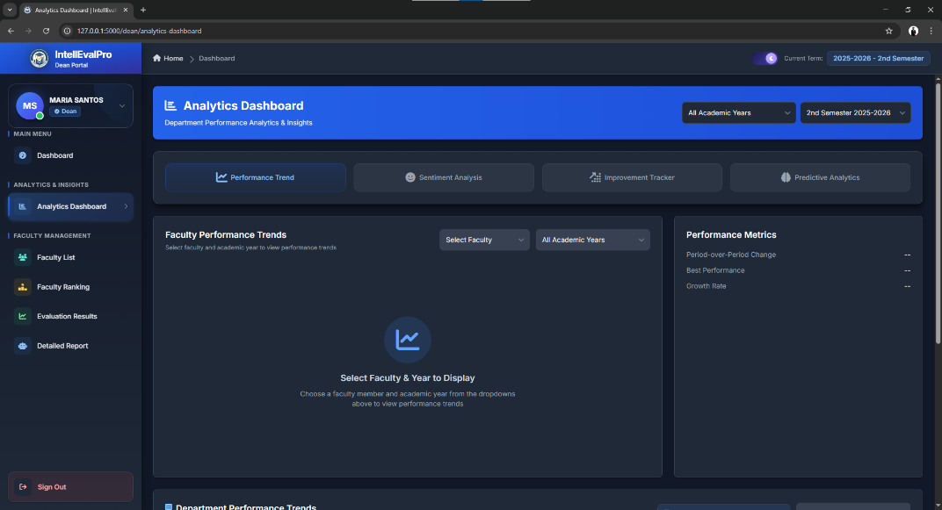

Figure 25. Analytics Dashboard

6.13 Archives and Activity Logs
Purpose
This module stores archived records and system activity information.
Procedure
- Log in as Admin or Superadmin.
- Open Archives or Activity Logs.
- Use filters to locate records.
- Review or export the information as needed.
Expected Result
Historical data and system activities are available for review.
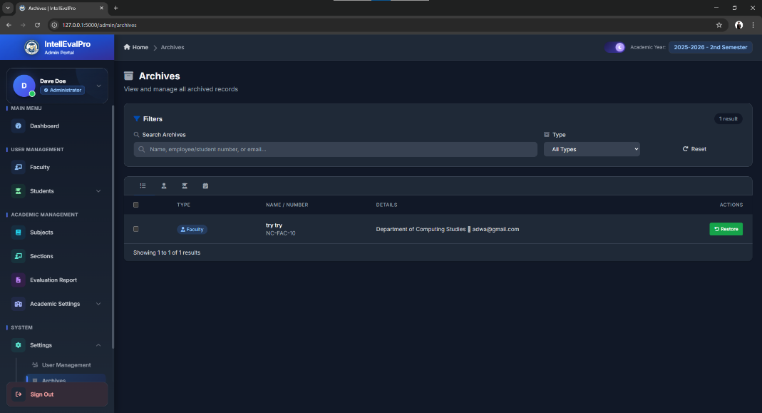

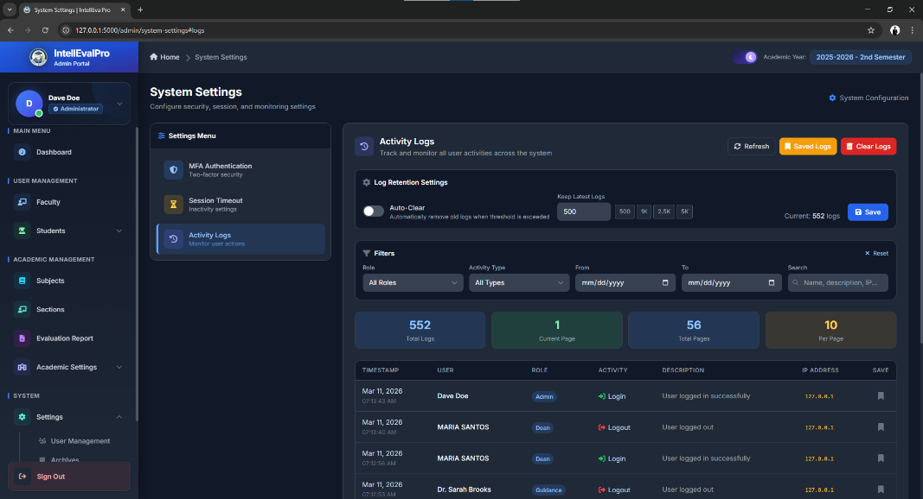

Figure 26. Archives or Activity Logs Page

7. Role-Based User Guide
7.1 Superadmin User Guide
Accessing the Dashboard
- Log in using a Superadmin account.
- Complete the required authentication steps.
- Open the Superadmin Dashboard.
Using System Features
- Review overall system status.
- Open Database Browser to inspect tables.
- Open System Health to monitor performance.
- Open Activity Monitor to review actions.
- Open Terminal Output to review warnings.
Managing Data
- Open Users.
- Add, edit, or delete user accounts.
- Save changes after verification.
Generating Reports
- Open the relevant monitoring page.
- Apply filters if necessary.
- Export logs or technical data.
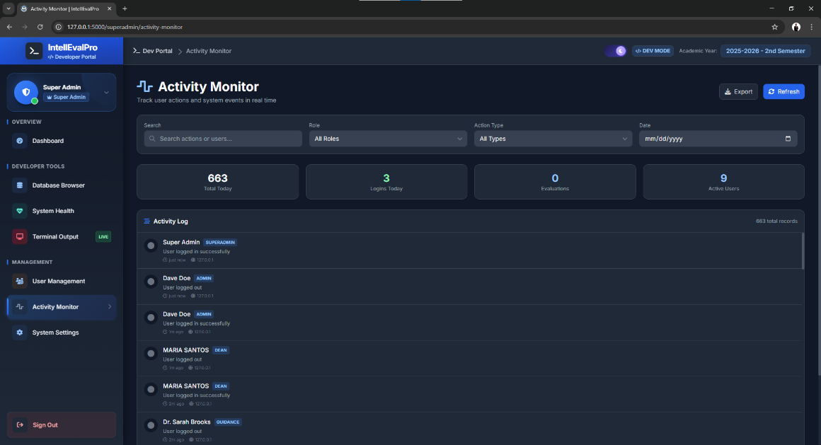

Figure 27. Superadmin System Monitoring Page

7.2 Admin User Guide
Accessing the Dashboard
- Log in using an Admin account.
- Open the Admin Dashboard.
- Review the summary cards and shortcuts.
Using System Features
- Manage academic years and terms.
- Manage evaluation periods.
- Manage faculty records.
- Manage student records.
- Manage subjects and sections.
- Manage users.
- View archives and logs.
Managing Data
- Use Add buttons to create records.
- Use Edit buttons to modify records.
- Use archive or delete options when allowed.
- Confirm that records are assigned correctly.
Generating Reports
- Open Evaluation Reports.
- Select the desired filters.
- Generate the report.
- Download the output.

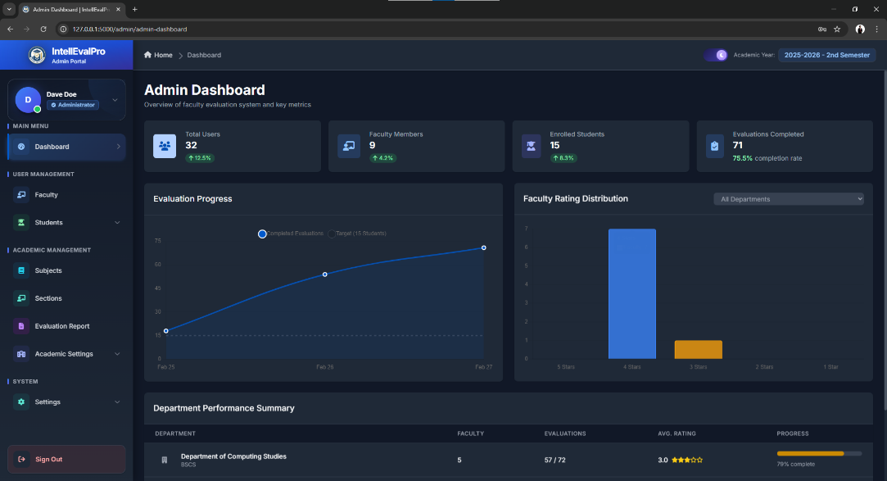

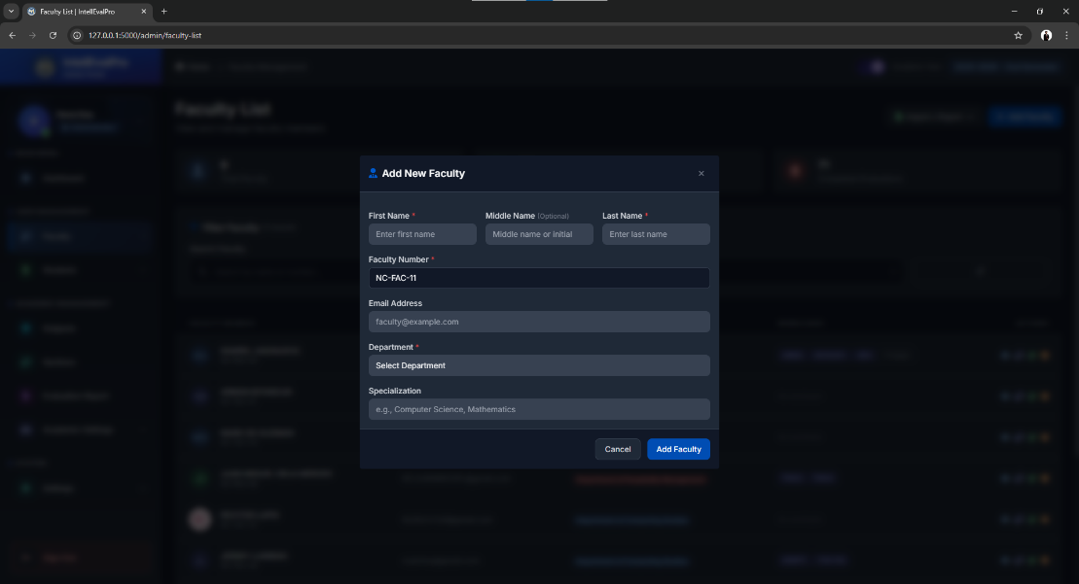

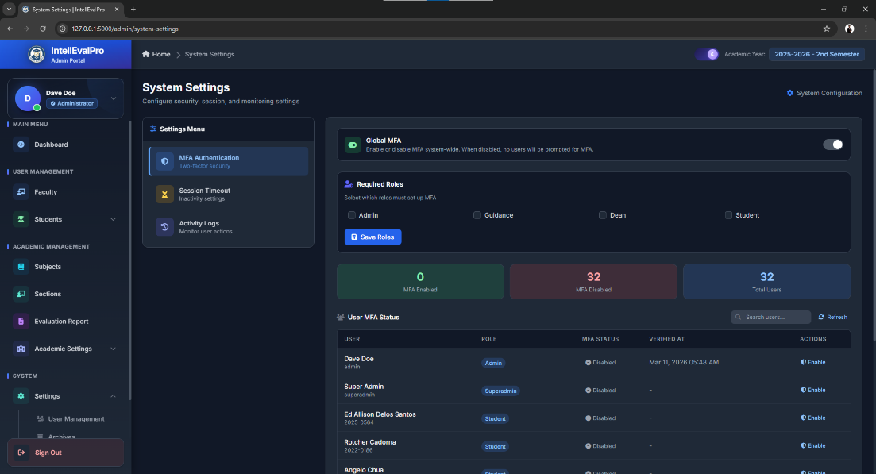

Figure 28. Admin Dashboard and Main Modules

7.3 Guidance User Guide
Accessing the Dashboard
- Log in using a Guidance account.
- Open the Guidance Dashboard.
- Review current evaluation statistics and ranking summaries.
Using System Features
- Manage evaluation periods.
- Manage questionnaires.
- Monitor evaluation completion.
- View results and comments.
- Open rankings and analytics.
- Grant or remove dean access when necessary.
Managing Data
- Update questionnaire categories and criteria.
- Maintain period schedules.
- Monitor faculty and student evaluation activity.
Generating Reports
- Open Evaluation Reports.
- Select the report scope.
- Generate PDF or Excel output.
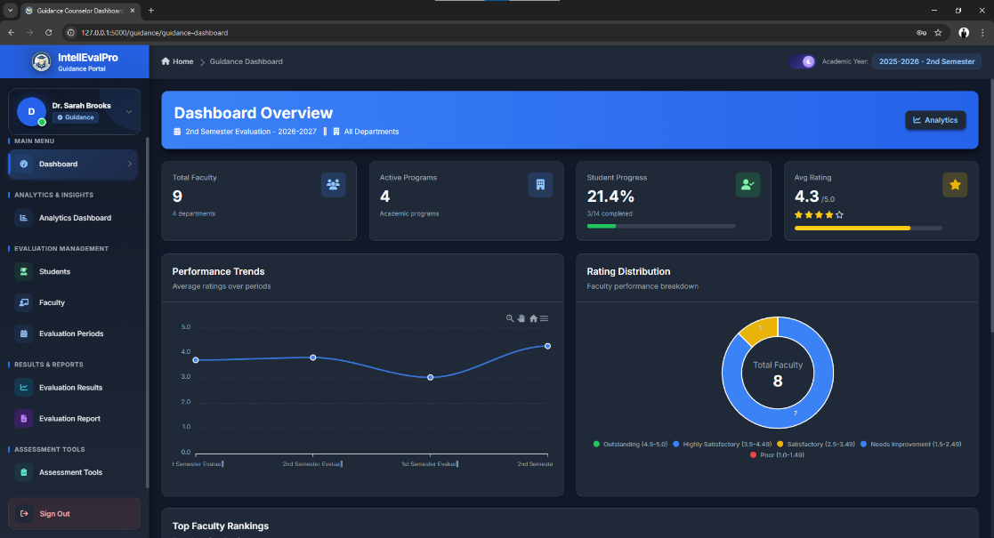
- Download the file.

Figure 29. Guidance Dashboard or Questionnaire Management Page

7.4 Dean User Guide
Accessing the Dashboard
- Log in using a Dean account.
- Ensure Guidance has granted access.
- Open the Dean Dashboard.
Using System Features
- Review department faculty list.
- Open department evaluation results.
- View faculty rankings.
- Review analytics and summaries.
- Open department reports.
Managing Data
The Dean mainly reviews information and does not manage core system records.
Generating Reports
- Open Evaluation Report.
- Select the desired period or faculty.
- Generate the report.
- Download the output file.
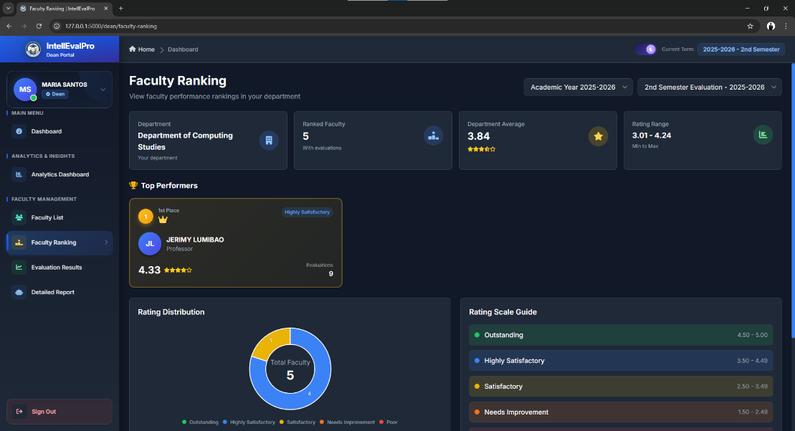

Figure 30. Dean Evaluation Results or Ranking Page

7.5 Student User Guide
Accessing the Dashboard
- Log in using a Student account during an active evaluation period.
- Open the Student Dashboard.
- Review pending evaluations and progress.
Using System Features
- Open Pending Evaluations.
- Select an assigned evaluation.
- Complete the rating form.
- Submit the evaluation.
- Open My Evaluations to view status.
- Open Settings to change your password if needed.
Managing Data
Students do not manage institutional records. Their main responsibility is to complete assigned evaluations.
Generating Reports
Students do not have report generation access.
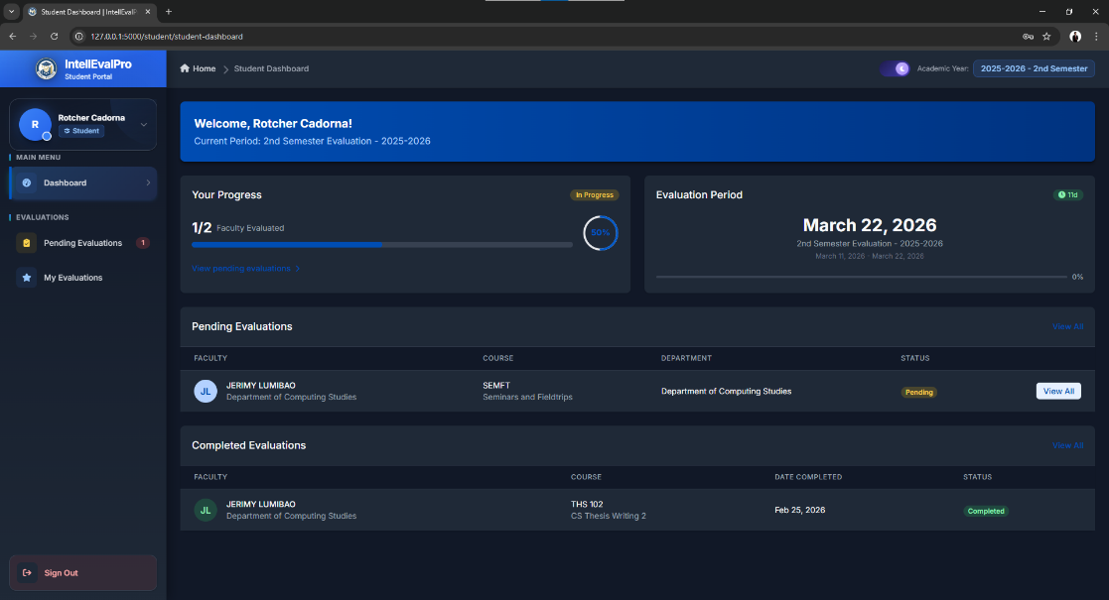

Figure 31. Student Dashboard or Pending Evaluations Page

8. Common Tasks
8.1 Creating a Faculty Record
- Log in as Admin.
- Open Faculty List.
- Click Add Faculty.
- Enter the required information.
- Save the record.
- Verify that the new faculty member appears in the list.
Expected Result

The faculty record is successfully added.

Figure 32. Adding a Faculty Record

8.2 Updating a Student Record
- Log in as Admin.
- Open Student List.
- Search for the student.
- Click Edit.
- Update the necessary information.
- Save the changes.
Expected Result
The student record is successfully updated.
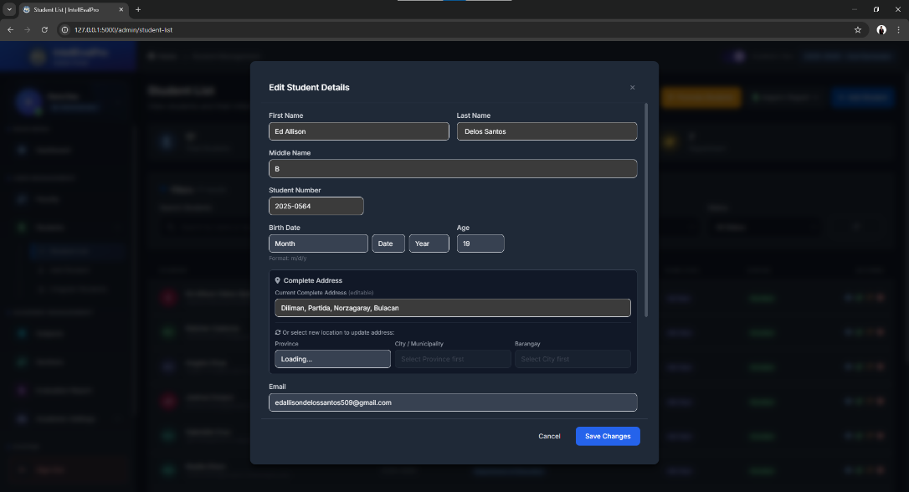

Figure 33. Editing a Student Record

8.3 Creating an Evaluation Period
- Log in as Admin or Guidance.
- Open Evaluation Periods.
- Click Add Evaluation Period.
- Enter the required details.
- Set the status.
- Save the record.
Expected Result
The evaluation period is created and becomes active when scheduled.

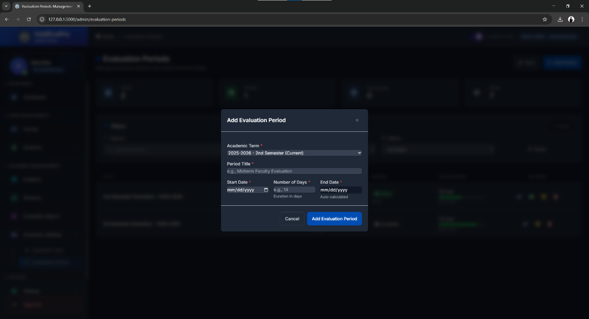

Figure 34. Creating an Evaluation Period

8.4 Submitting an Evaluation
- Log in as Student.
- Open Pending Evaluations.
- Select a faculty evaluation.
- Answer all required questions.
- Add comments if desired.
- Click Submit.
Expected Result
The evaluation is recorded as completed.
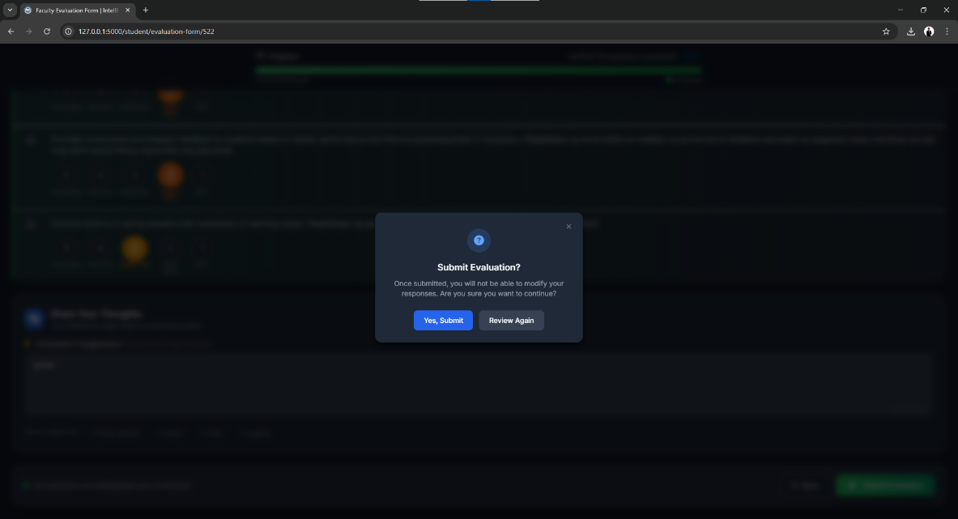

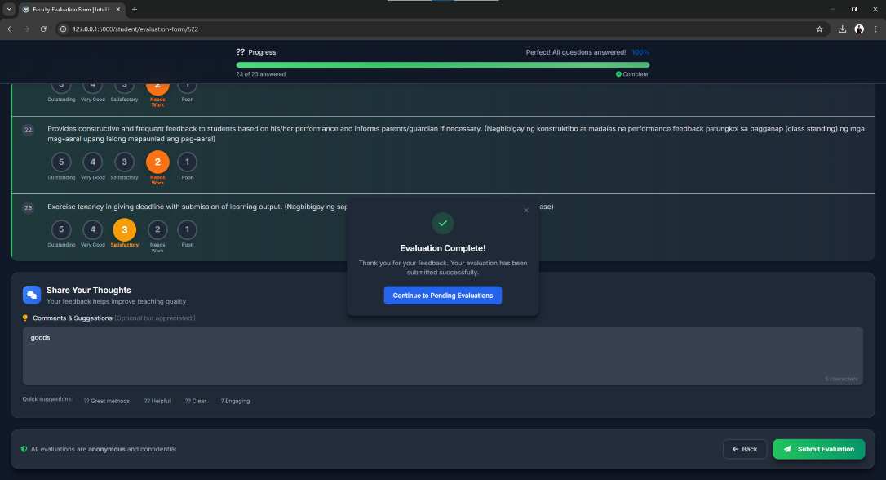

Figure 35. Evaluation Submission Process

8.5 Generating a Report
- Log in as Admin, Guidance, or Dean.
- Open Evaluation Reports.
- Apply the needed filters.
- Select the output format.
- Generate the report.
- Download the report.
Expected Result
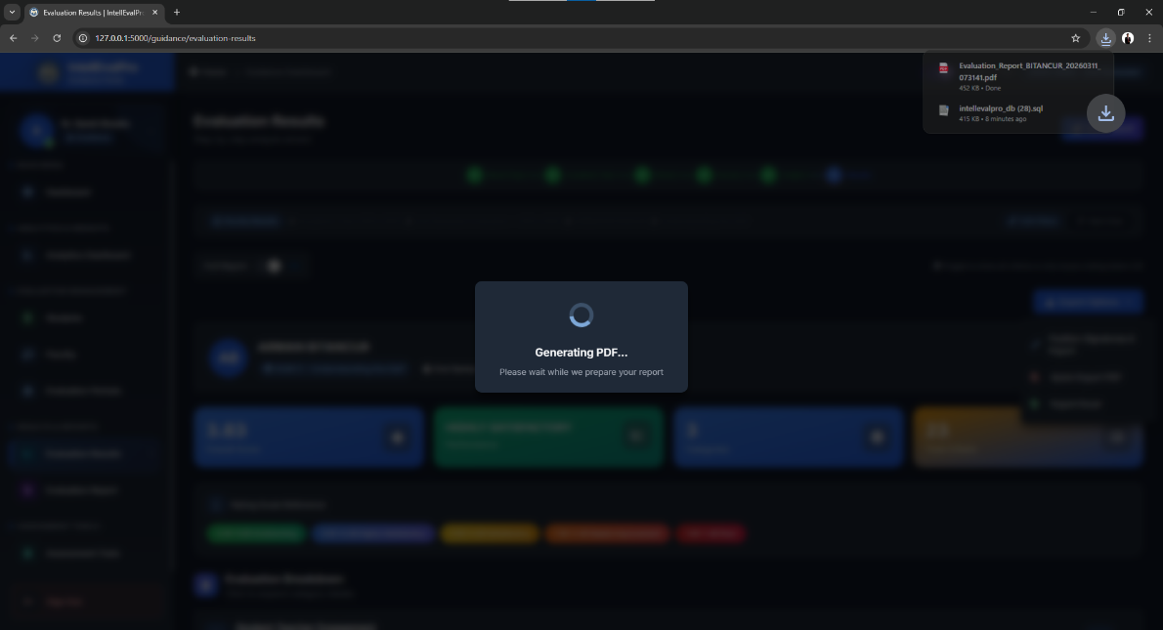
The report is created and available for printing or review.

Figure 36. Report Generation Process
9. Troubleshooting
9.1 Invalid Username or Password
Possible Cause
The entered login credentials are incorrect.
Solution
- Re-enter the correct username and password.
- Check for typing errors.
- Use Forgot Password if necessary.
- Contact the administrator if the issue continues.
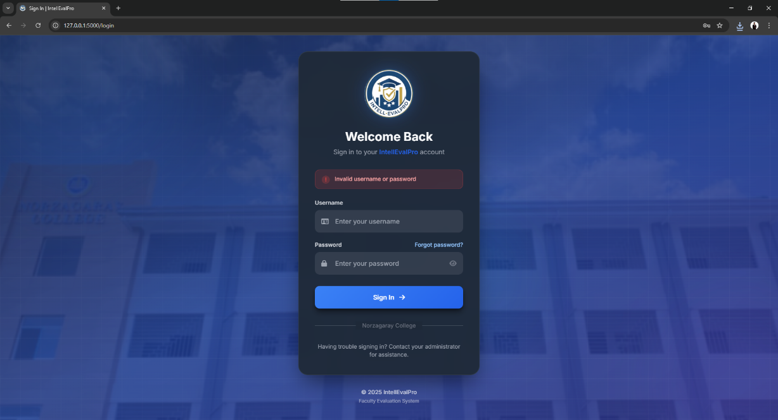

Figure 37. Invalid Login Message

9.2 No Active Evaluation Period
Possible Cause
The evaluation period is not currently open.
Solution
- Wait for an active evaluation period.
- Contact the Admin or Guidance office.
- Try logging in again during the active schedule.
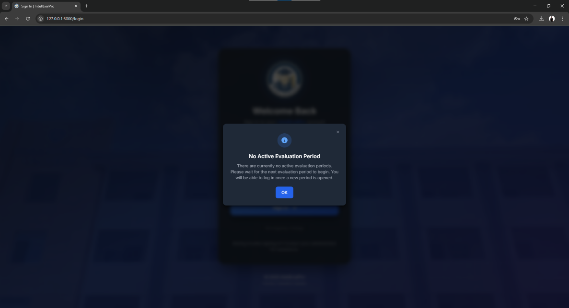

Figure 38. No Active Evaluation Period Notice

9.3 Dean Access Denied
Possible Cause
Guidance has not yet granted access to the dean account.
Solution
- Contact Guidance.
- Request account access approval.
- Log in again after approval.
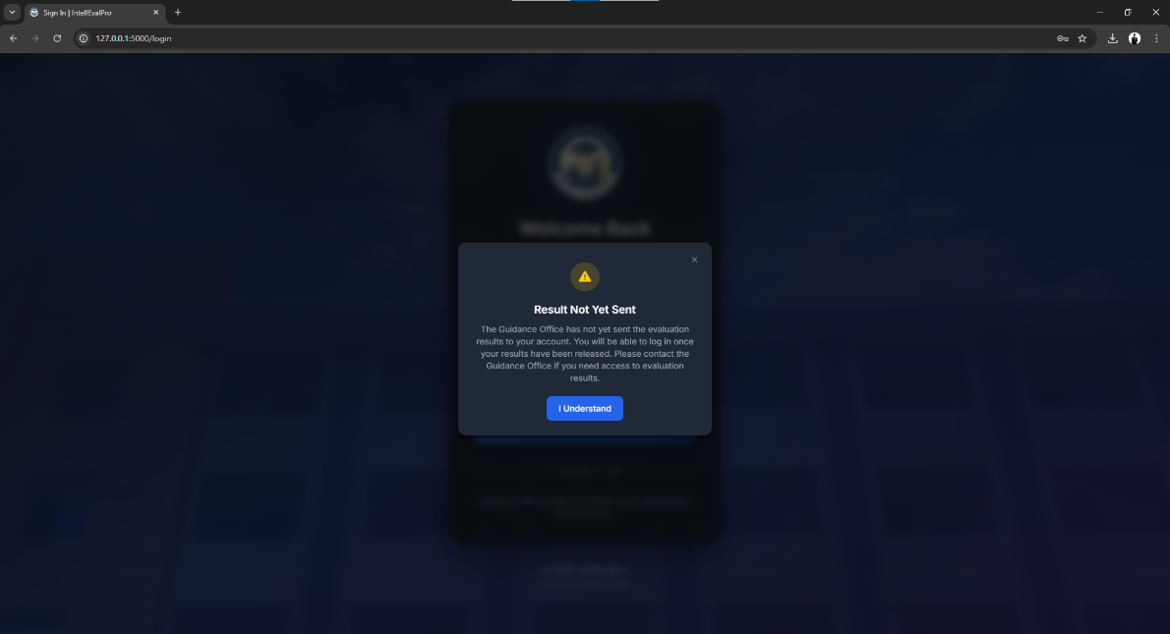

Figure 39. Dean Access Denied Message

9.4 Password Reset Email Not Received
Possible Cause
The message may be delayed or filtered.
Solution
- Check the spam or junk folder.
- Verify the registered email address.
- Submit the request again.
- Contact the administrator if needed.

9.5 Unable to Submit Evaluation
Possible Cause
The form may be incomplete, the evaluation period may be closed, or the session may have expired.
Solution
- Complete all required items.
- Confirm that the period is active.
- Log in again if the session expired.
- Contact support if the issue remains.

9.6 Page Not Displaying Properly
Possible Cause
There may be a browser, cache, or network issue.
Solution
- Refresh the page.
- Clear browser cache.
- Use an updated browser.
- Check the internet or network connection.
- Log in again if necessary.

10. Logout Procedure
Proper Logout Steps
- Open the profile menu or navigation menu.
- Click Logout.
- Wait for the system to clear the session.
- Confirm that you are redirected to the Login page.

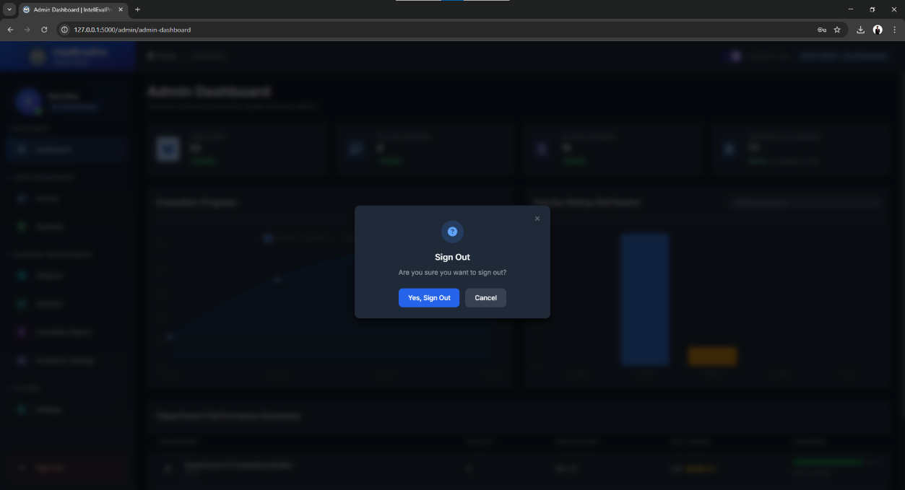

Figure 40. Logout Option
Importance of Proper Logout
- It protects the account from unauthorized access.
- It is important when using shared computers.
- It helps end the session securely.

Conclusion
IntellEvalPro is a centralized Faculty Evaluation System that supports faculty evaluation workflows from system setup to reporting. It allows Admin, Guidance, Dean, Student, and Superadmin users to perform their assigned responsibilities in a secure and organized environment. By adding screenshots at the marked locations above, the manual becomes more suitable for Microsoft Word documentation, thesis presentation, and end-user training.

